Name: _____________________ Class:__________ Date:__________
Instructions: Write answers in the right-hand column. Score: ___________ / 50 marks
Section A— Multiple choice (10 marks)

1 | Fossils such as trees that have their minerals replaced by other minerals such as silica over many millions of years are often referred to as being:  A carbonised  B solidified  C petrified  D mummified | C | 1
2 | Scientists who study fossils and use them to try to understand the history of life are called:  A geologists  B palaeontologists  C sedimentologists  D archaeologists | B | 1
3 | The Mesozoic era consisted of three Periods, called the Triassic, Jurassic and Cretaceous. This era ranged from 251 to 65 million years ago. During this time, the most dominant life form was:  A mammals  B birds  C amphibians  D dinosaurs | D | 1
4 | Archaeopteryx is an important fossil because it:  A is the oldest dinosaur fossil ever discovered  B had all the features of modern birds  C had features of both birds and dinosaurs  D was a dinosaur that laid eggs | C | 1
5 | Fish that appeared in the fossil record between ray-finned fish and amphibians and that had bones in their fins were known as:  A ichthyosaurs  B lobe-finned fish  C bony fish  D tetrapods | B | 1
6 | The famous fossil site in South Australia that has a geological period named after it is:  A Emu Bay  B Kangaroo Island  C Ediacara  D Dinosaur cove | C | 1
7 | Amphibians, reptiles, birds and mammals as a group are known as:  A tetrapods  B arthropods  C ipods  D ichthyopods | A | 1
8 | Which of the following is an absolute dating method?  A stratigraphy  B fluorine dating  C index fossils  D tree rings | D | 1
9 | A cast is an indirect fossil formed when:  A the body of an organism is filled with sediment that then turns to rock  B a mould becomes filled with sediment that turns to rock  C an impression of the outside of the body forms in rock  D a shell turns to rock | B | 1
10 | Living stromatolites are found in:  A Western Australia  B South Australia  C Queensland  D Victoria | A | 1

Section B— Short answer (30 marks)

- ` | Discuss three types of environments where soft tissues are likely to be preserved in fossils | Any three of:  permafrost—permanently frozen ground that prevents bacteria growing and therefore stops decay  tar—sticky oil that prevents bacteria growing and stops decay  peat—decaying moss that is very acidic and is low in oxygen, preventing growth of bacteria  dry air—desert winds dehydrate animals quickly. This will prevent bacteria from growing.  amber—organisms become trapped in sticky plant sap that solidifies and excludes oxygen and moisture, preventing decay. | 3
 | Compare how carbon film, replacement and mould fossils form. | Carbon film—organic compounds partly decay leaving a thin deposit of carbon  Replacement—solids such as bones and shells slowly lose the minerals molecule by molecule over many millions of years. The original molecules are replaced by other minerals like silica.  Moulds form when the outside of the body is pressed into sediments that then turn into rock. The original dissolves and leaves the impression of the outside of the body in the rock. | 3
 | Explain why the fossil record is incomplete. | Any three points:  Many organisms do not live where they can quickly become covered by sediments.  Many organisms live where they will be quickly consumed by scavengers.  Many organisms do not have hard body parts that can withstand crushing.  Many organisms have softer body parts that quickly decay. | 3
 | Describe three characteristics that determine if a fossil is a suitable index fossil. | Any three of the following.  Species must:  - have been widespread  - have lived in a fairly narrow time period  - have been abundant  - be easy to identify. | 3
 | Explain how the geological time scale was constructed. | Index fossils were used to place strata in an order from the earliest strata to the latest.  Radioactive dating (and other absolute dating methods) was done on as many layers as possible to identify when particular index fossils lived.  The two sets of data were put together to form a sequence from the earliest strata to the newest strata. | 3
 | List the sequence in which the following vertebrate fossil groups appear in the fossil record: birds, reptiles, ray-finned fish, amphibians, lobe-finned fish. | Ray-finned fish, lobe-finned fish, amphibians, reptiles, birds | 2
 | Explain the importance of the Ediacaran fauna in the history of life on Earth. | It was the first time that multicellular animals appeared in the fossil record. These fossils seemed to be the ancestors of many later groups in the fossil record. | 2
 | Consider the three strata shown below. They occur in three different sites: A, B and C. Each layer has been numbered.  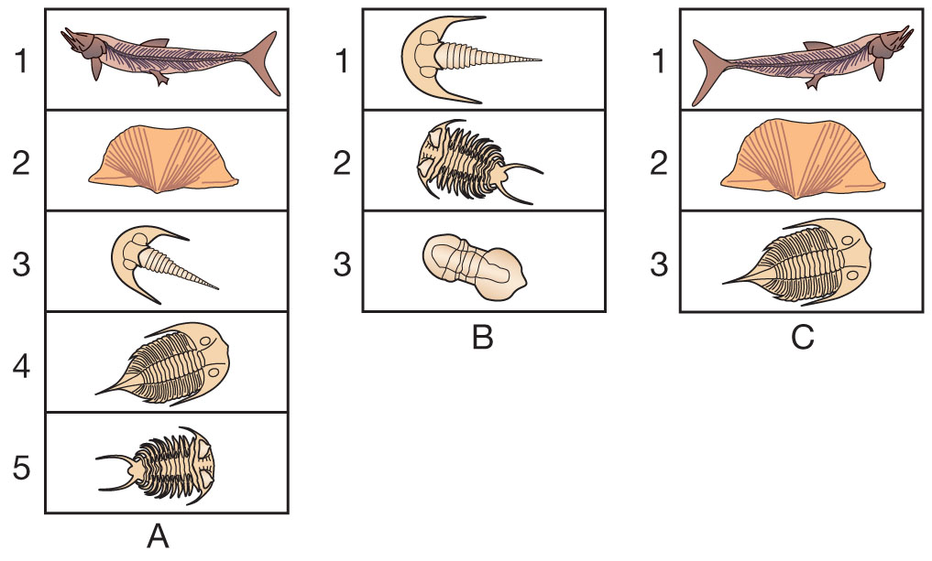  a Identify the oldest stratum over the three sites. (Give site and layer number.)  b Identify the youngest stratum in the three sites.  c Identify a layer from site A that you would expect to be found at site B, but which did not occur there.  d Identify the main group of animals that has been used as index fossils to date these three sites. | a B3  b A1 or C1  c A4  d Trilobites | 4
 | Refer to Figure 1 at the end of this test.  The graph shows the decay curve for potassium-40 to argon (i.e. potassium–argon dating).  a Use the graph to determine the age of a fossil that has 25% (one quarter) of its radioactivity remaining.  b Use the graph to determine the age of a fossil that had 75% (three quarters) of its radioactivity remaining.  c Potassium-40 occurs in magma and in volcanic ash. Propose how this fact could be used to date fossils. | a 2502 million years  b 625 million years  c Fossils may be found in sedimentary rock formed from volcanic ash, so potassium–argon dating could be used. | 3
 | Propose a suitable dating method for each of the following:  a dating a dinosaur bone found in a volcanic ash layer  b dating a piece of mammoth skin tissue recovered from permafrost in Siberia  c proving that two human skulls were not from the same location  d dating two rock layers from different countries that contained fossils of the trilobite Dalmanites, but which did not contain any radioactive material | a potassium–argon dating  b radiocarbon dating  c fluorine dating  d Compare the trilobite fossils with others of known age from elsewhere. If they are the same species then the ages should be similar. | 4

Section C— Thinking scientifically (10 marks)

 | Some trilobite fossils are found in the centre of New South Wales. We can conclude that:  A The Australian landmass lifted up out of the sea.  B Freshwater trilobites must have existed.  C The sea once covered that part of Australia.  D Land trilobites must have existed. |  | C | 1
 | Hard objects are more likely to form fossils. Which of the following types of animal would be least likely to form a fossil?  A parasitic tapeworm  B trilobite  C bird  D shark |  | A | 1
 | Which of the following environments would be least likely to fossilise soft tissue?  A bottom of a deep sea  B a peat swamp  C permafrost  D tropical rainforest |  | D | 1
 | Fossils often form when sediment is laid down on top of animal or plant remains. Which of the following types of animal would probably have the best fossil record?  A fish  B reptiles  C birds  D mammals |  | A | 1
 | A bone placed in acid effervesces (fizzes) and loses its hardness. It can be bent easily and is flexible. The reason why skeletons disappear in some fossils is that:  A water reacts with calcium salts in bone forming soluble salts and carbon dioxide.  B acids dissolve the hard calcium salts and bacteria decompose the protein.  C calcium salts and protein are decomposed by bacteria.  D bones contain protein that is flexible, giving them their great strength. |  | B | 1
 | Calcium carbonate forms the shells of many marine organisms such as molluscs. Calcium carbonate is almost insoluble in water at room temperature and pressure. However, at higher pressures and lower temperatures it becomes more soluble. From this information, which of the following is a reasonable hypothesis?  A Fossil shells are more likely in the deep ocean than in shallow seas.  B There will not be any fossil shells found in warm shallow water.  C The deep ocean should have fewer fossil shells than shallow seas.  D Fossil shells will not be found near oceans. |  | C | 1
 | The half-life of potassium-40 is 1251 million years (see Section B question 9 graph). Of all the rocks containing potassium-40, which ones would now have at least 50% of their radioactivity remaining?  A all those igneous rocks formed in the last 1251 million years  B none  C all those igneous rocks formed each day  D about one twelfth (1/12) of all igneous rocks |  | A | 1
8 | An experiment on radioactive decay used a jar containing 100 white counters with one side marked with a black cross (representing a decayed atom). The counters were shaken up, tipped out on a desk and the number of black crosses (decayed atoms) counted. The decayed atoms were removed and placed in a beaker. The remaining counters were shaken up and the process repeated again and again until no counters remained.  If a graph was drawn of the total number of the 100 atoms that were ‘decayed’ over time (i.e. the number in the beaker), select which graph would be the most likely.  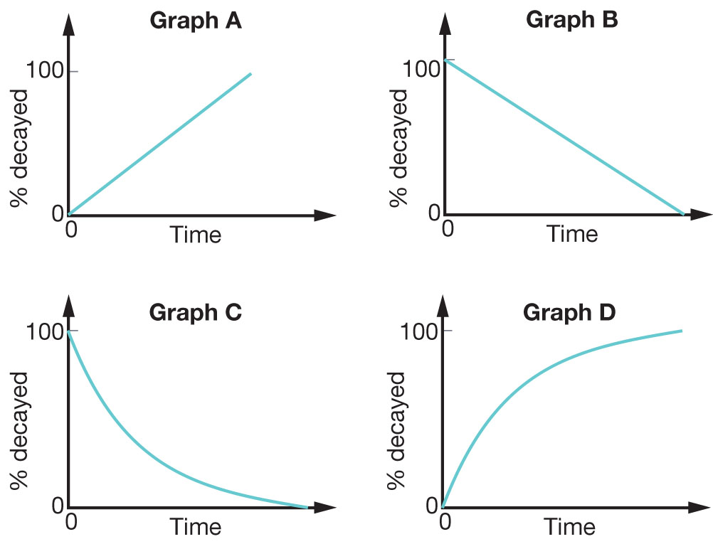 | D |  | 1
9 | Geologists searching for oil often look for particular fossils of plant pollen. These are used as index fossils to locate sedimentary rock layers of the right type and age. Why would geologists search for particular types of pollen fossils?  A The pollen was shed in such large amounts that it decomposed to form oil.  B The trees that shed the pollen grew in an environment and time when much of the oil was being formed.  C The pollen is useful because it can tell geologists how much oil is in the area.  D The pollen was from a particular type of tree that decomposed to form the oil. | B |  | 1
10 | The amount of potassium in a human body is about 0.2% by mass. Potassium-40 always makes up 0.0117% of any sample of potassium. In a 70 kg human, approximately how much potassium-40 would there be?  A 0.002 g  B 0.16 kg  C 0.016 kg  D 1.6 g | D |  | 1

This graph relates to Section B question 9.
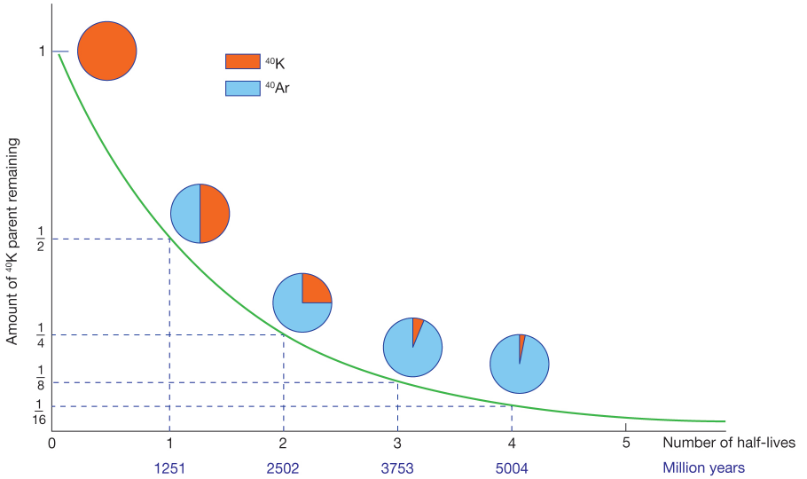
Figure 1
Decay curve for potassium-40 to argon

